**IMS Data Check Work Instructions**

1. Locate the files for the respective project in the working files.
2. Save as: 04XX mmm-yy IMS Data Check.
3. Copy column A-G from ‘Curr Baseline’ tab to ‘Prev Baseline’ tab.
4. Copy column A and B from ‘CA Check’ tab to ‘Prev CA-WP’ tab.
5. Navigate to ‘Baseline Changes’
   1. Turn filters on.
      1. Column K, L, M, N, P, Q, R, S should all be 0 before starting with new data.
6. Navigate to ‘BCR Change List (Doreen Rpt)’ tab.
   1. Column A-E will be filled in appropriately.
      1. Find current month BCRs.
         1. Open Fortis.
         2. Open ‘Supplemental by ID; Enter Supplemental ID number.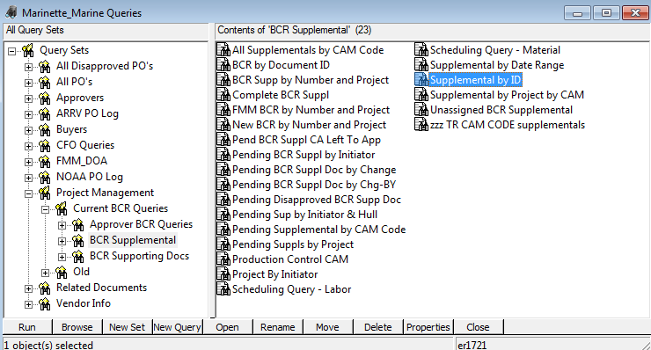
         3. Launch the supplemental.
         4. Copy the Control Account, WP, Hours or Material Dollars and BCR.
            1. Note: WP will have either Hours OR Material Dollars – not both. Make sure placing in correct column.
         5. Column F-I are formula driven and will populate automatically.
         6. Once all data has been entered from Fortis- remove spaces from Column A and B.
   2. Copy column A, B and E to ‘Master BCR Change List’ Tab.
      1. Turn filters on.
      2. Select Column B.
      3. Navigate to ‘Home’ – Conditional Formatting – Highlight Cells Rules – Duplicate Values.
      4. Sort Column B A-Z.
      5. If WP is red – Combine the two BCRs in Column C – See example below:
         1. Example – Copied over data:
            1. 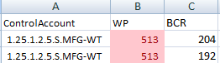
         2. Example – After formatting:
            1. 
7. Navigate to ‘Baseline Changes’ Tab.
   1. Copy Column A and B from ‘Curr Baseline’ tab.
      1. Upend to the bottom of Column A and B on ‘Baseline Changes’ tab.
      2. Highlight Column A and B after pasting the current baseline.
         1. Data Tab on toolbar – Remove duplicates
      3. Copy formulas from Column C through Column X so all WP’s have formulas related.
   2. Turn filters on Row 1.
      1. Column O – Filter for ‘No BCR’.
      2. Column K, L, M, N should all be 0; there should be no change if there is no BCR.
         1. If so, move on to next step.
         2. If not, investigate to resolve the issue.
      3. Column P, Q, R, S should be 0 (This is the difference between IMS and Cobra).
         1. If so, move on to next step.
         2. If not, investigate to resolve the issue.
      4. Column O: Filter for ‘No BCR’
         1. If milestone (Column V) is yes – Move onto next step.
         2. If milestone (Column V) is no – K, L, M, N should all be 0. If not 0, need to investigate.
8. Navigate to ‘CA Check’ tab.
   1. Filter on Column D ‘Change’ for Yes.
      1. If yes- Column E (BCR?) should have a BCR associated with the change.
      2. If no – This means there is a change in the control account, but no BCR was associated with this change – need to contact scheduling.
   2. Filter on Column E (BCR?) for everything but 0.
      1. Column G should be yes for all.
         1. If no – confirm with scheduling which control account is correct (BCR or IMS).
         2. If yes – proceed.
   3. Basically, the main points of this check are as follows:
      1. If there is a change in Column D; there should be a BCR associated with it.
      2. If there is a BCR in Column E; Column G should have Yes for all because that is saying that the control accounts listed on the BCR match the control accounts listed in the IMS.